Intermountain Voice & Swallowing Center

Muscle Tension Dysphonia

What is Muscle Tension Dysphonia?
Muscle tension dysphonia (MTD) is a condition in which the vocal cords and supporting structures may be healthy, but they are working inefficiently. MTD is caused by the throat muscles being too tight as they try to make sound for speaking and singing. The person with MTD may feel that it takes more effort to talk, voice strain, running out of air during speech, and becoming vocally “fatigued” after speaking. Individuals may feel a soreness or pain in the ear, jaw, neck, throat, and possibly shoulders. In some instances, one may feel more tightness or restriction when swallowing.

Problems Related To Muscle Tension:
- Pain or tension in the throat when speaking or singing.
- A voice that sounds rough, hoarse, gravely, raspy, weak, breathy, airy, voice is only a whisper, strained, pressed, squeezed, tight, or tense.
- A voice that suddenly cuts out, breaks off, changes pitch, or fades away.
- A voice that becomes weaker with use.

Causes Of Muscle Tension
MTD may develop from trying to compensate for a weak vocal fold, a vocal fold lesion, vocal fold swelling following a cold, voice overuse from high vocal demands, or voice “misuse”.

Reflux may be one factor that contributes to the tissues becoming swollen and the muscles needing to work differently to compensate. Swallowing weakness may be another underlying factor contributing to vocal strain.

In some cases, there may be underlying physical, emotional, or psychological stress contributing to the dysphonia. Voices are very responsive to emotion and help to convey a spectrum of emotions including happiness, sadness, and anger. The saying, “I’m all choked up” is more than just a figure of speech. As such, additional therapies, such as massage therapy or counseling services, may also be beneficial in conjunction with voice therapy.

Physical therapy may be indicated if there is TMJ, upper body pain, or other neck issues.

Why Voice/Speech Therapy?
Voice therapy is a non-invasive, yet effective approach that involves working with a speech-language pathologist to manage disregulated muscle tension and restore your functional voice. In addition to retraining laryngeal muscles over the course of several weeks, therapy activities include learning resonant voice exercises, reviewing healthy vocal habits and behavioral changes, and retraining breathing. These will be adapted in a home exercise program to assist in eliminating voice symptoms and practicing your “new” voice outside of your therapy sessions. These exercises will help you manage your MTD throughout your therapy and after you have been discharged.

What Should I Expect?
Recovery from MTD can be varied. Many patients note improvement after just a few sessions of voice therapy. However, the longer the tense voicing pattern has been in place, the more challenging it is to change and sustain good muscle reposturing. Recovery relies on an accurate diagnosis from an otolaryngologist and speech-language pathologist, therapy with a speech-language pathologist skilled in voice treatment, and the motivation in addition to compliance from the patient to improve.

References:
R. H. Colton, J. K. Casper, and R. Leonard, Understanding Voice Problems: Perspective for Diagnosis and Treatment, Lippincott Williams & Wilkins, Baltimore, Md, USA, 4th edition, 2011.

N. Roy. Functional Dysphonia. Current Opinion in Otolaryngology and Head and Neck Surgery, Vol. 11, No. 3, pp. 144–148, 2003.

http://www.swedish.org/about/blog/may-2013/what-is-muscle-tension-dysphonia-mtd

Information compiled by Heather Elwell, MS, CCC-SLP and Camille Smith, MS, SLP


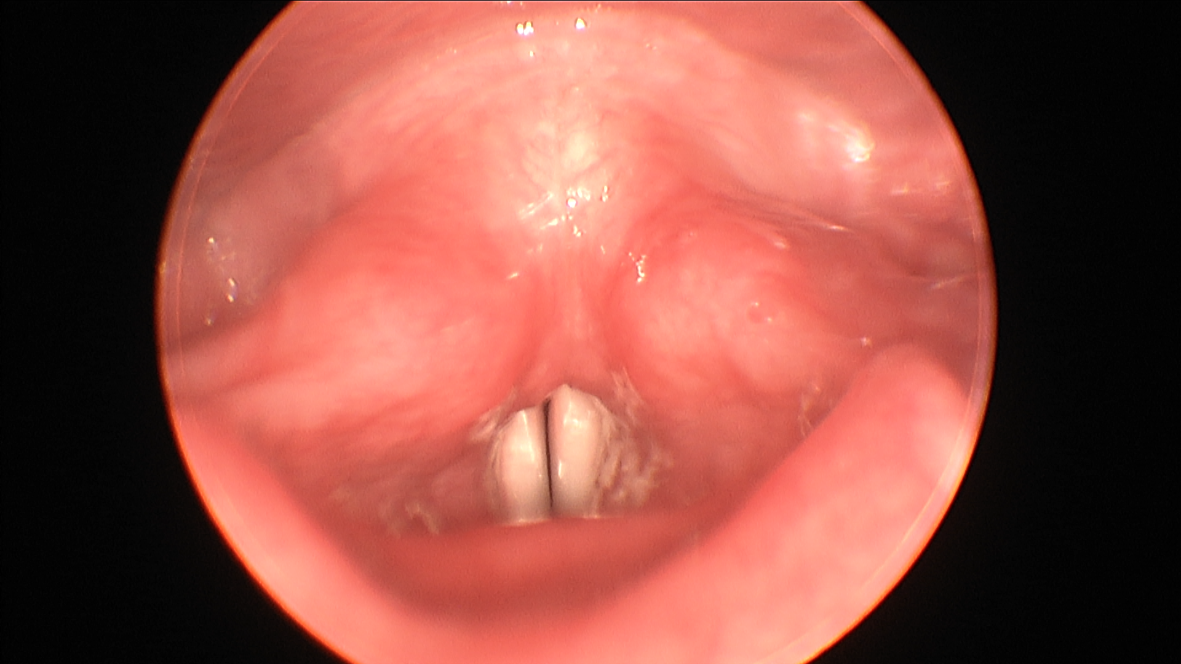

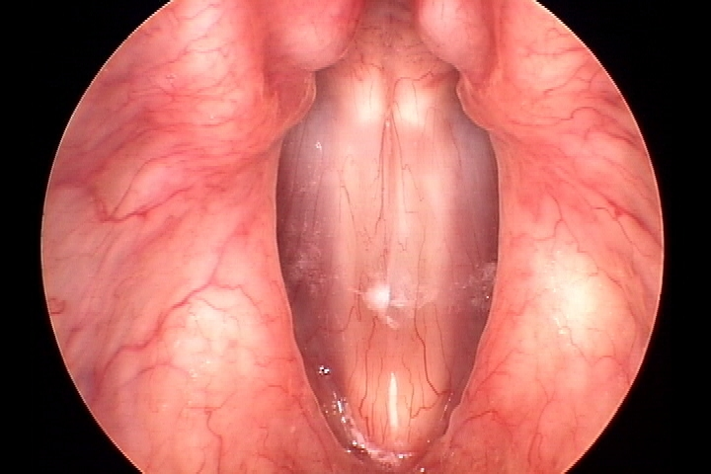

View of normal vocal folds closed.

